

Dear Parents & Students attending Crossland, Friendly, Oxon Hill & Potomac High Schools,

The Coalition for Public Safety Training in Schools, Inc. in partnership with Century Engineering Inc. is offering paid engineering internships for high school juniors and seniors of Crossland, Friendly, Oxon Hill and Potomac High Schools only.

The deadline to apply is fast approaching - May 14th. Please see flyer below for details. The flyer says 2021, but should be 2022.

This is an excellent opportunity for our District 26 high school students, especially those interested in STEM, so please take advantage of this opportunity and share with your neighbors.



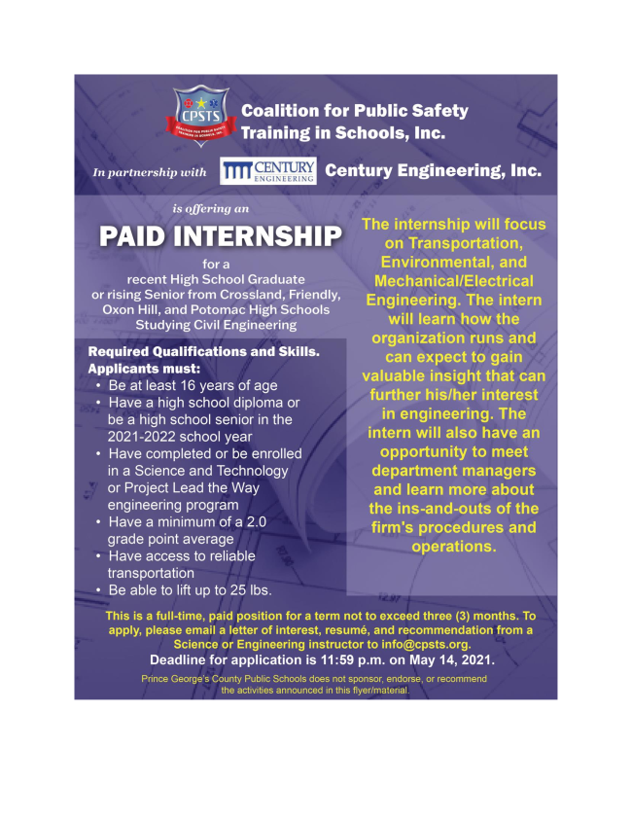

Sincerely,
Tamara Davis Brown
A Name You Know, A Voice You Trust.
To make a contribution to my campaign, click here: DONATE, or mail checks payable to Tamara Davis Brown for Prince George's County, P.O. Box 1292 Clinton, MD 20735.

  By Authority: Tamara Davis Brown for Prince George's County, Janelle Wright, Treasurer
  

