GETHSEMANE UNITED METHODIST CHURCH
910 ADDISON ROAD SOUTH
CAPITOL HEIGHTS, MD 20743
REVEREND RONALD E.F. TRIPLETT, LEAD PASTOR
VIRTUAL BIBLE STUDY SESSIONS
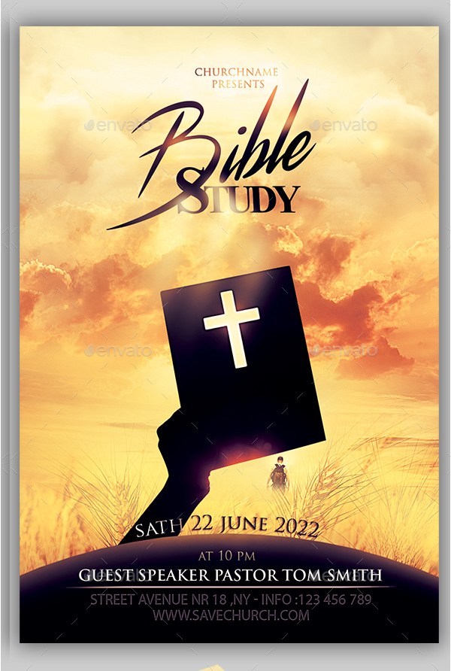
We cordially invite you to come join us on the 1st and 3rd Thursday of each month as we gather together to glorify God through fellowship with one another and to study God’s word, The Bible.
MEN’S BIBLE STUDY
Brother Donald Haynes – Facilitator
Resources Needed: “Our Daily Bread”

To get a copy of “Our Daily Bread” please call (301) 336-1219
1ST & 3rd THURSDAY EACH MONTH
7:00 - 8:00 PM
September 16 – December 16, 2021
https://zoom.us/j/3013361219

Dial In# +1 301 715 8592 US (Washington D.C) Meeting ID: 301 336 1219

