GETHSEMANE UNITED METHODIST CHURCH
910 ADDISON ROAD SOUTH
CAPITOL HEIGHTS, MD 20743
REVEREND RONALD E.F. TRIPLETT, LEAD PASTOR
VIRTUAL DISCIPLE/BIBLE STUDY SESSIONS
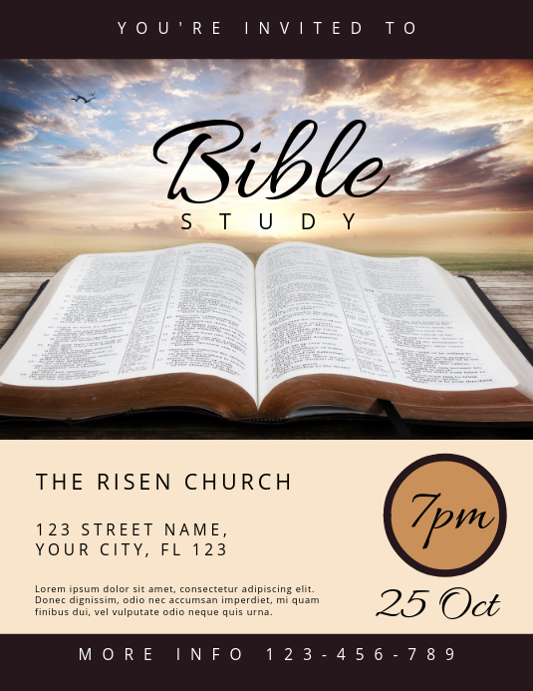
We cordially invite you to come join us each week as we gather together to glorify God through fellowship with one another and to study God’s word, The Bible.

TUESDAY COMMUNITY BIBLE STUDY: “THE END TIMES”
Reverend Ronald E. F. Triplett, Facilitator
12:00 NOON – 1:00 PM

Resources Needed:
“The Non-Prophet’s Guide to the End Times” by Todd Hampson (Both Book & Workbook)
AND
“Genesis to Revelation: A Comprehensive Verse-by-Verse Exploration of the Bible – Ezekiel – Daniel” by Linda B. Hinton
To get information of how to purchase the books, please call (301) 336-1219

September 21 – December 14, 2021
https://zoom.us/j/3013361219

Dial In # +1 301 715 8592 US (Washington D.C)
Meeting ID: 301 336 1219

