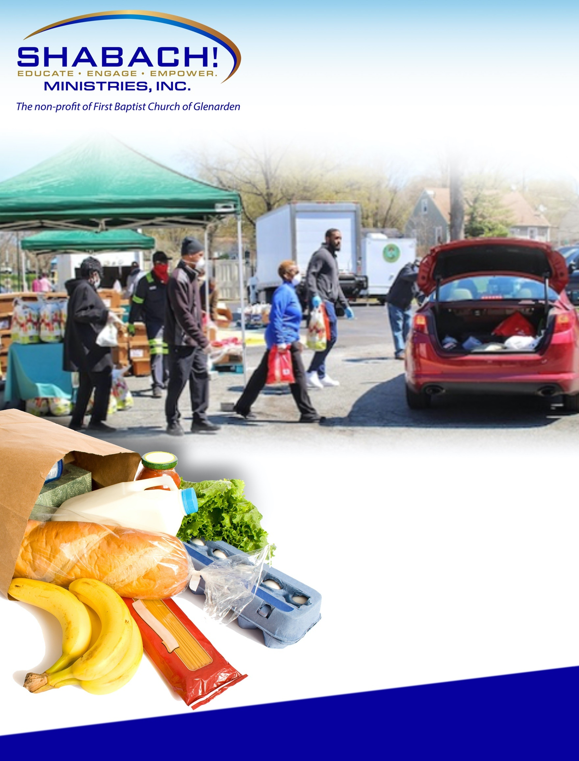
*ONLY ONE DISTRIBUTION PER CAR*WHILE SUPPLIES LAST
For more information, Call 240 532-7003

Thursday, February 18, 2021
12:00 noon– 2:00 p.m.

ST. John Evangelist Catholic Church/School
8912 Old Branch Avenue
Clinton, MD 20735

*NO WALK UP PLEASE*
**RAIN OR SHINE**
We will distribute diapers-n-wipes too!
SHABACH!
MINISTRIES, INC.
COMMUNITY
GROCERY GIVEAWAY

