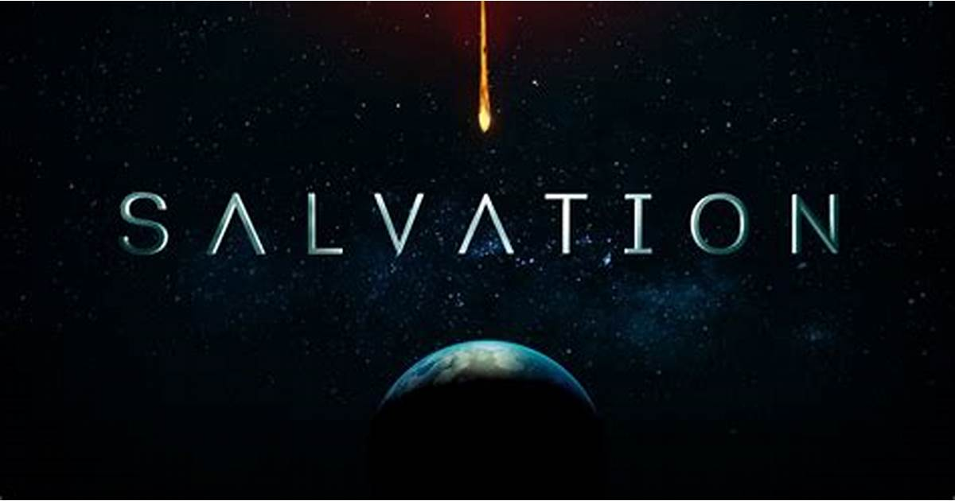
GETHSEMANE UNITED METHODIST CHURCH
910 Addison Road South
Capitol Heights, Maryland 20743
Reverend Ronald E. F. Triplett, Lead Pastor

The Gethsemane Evangelism Ministry Team invites you to attend:
“A Sharing Message of Salvation”
Monday Evening, February 15, 2021
Virtual Zoom Platform - 6:30 – 8:00 PM
Please come and join us! Sit in on an evening of inspiration!
Join Zoom Meeting
https://zoom.us/j/3013361219
Meeting ID # 301-336-1219
Phone-In #
1-301-715-8592
“For God So Loved The World, He Gave His Only Begotten Son, That Whoever Believes In Him, Shall Not Perish, But Have Eternal Life” – John 3:16

